**COMPUTER GRAPHICS MINI PROJECT**

**PROJECT NAME: ENDLESS FLYER**

**GROUP MEMBERS: PRATHAMESH THAKUR: D7A -63**

**SHREYAS SAWANT: D7A-55**

**HARIHARAN IYER: D7A-22**

**ABSTRACT:**

This project explores the use of physical law (gravitational law) for game development. The game in its exactness follows rules similar to that of the original game known as flappy bird.

The rules and regulations of the game are very basic and easy to understand. The game scenario puts the player in control of hovering a bird on the screen with moving obstacles of walls.

The goal of the game is to get through the opening in the obstacles without colliding with them. The game is implemented in C++. The case study discusses the use of simpler motion and modification to build the abstraction. The game is in single-player mode.

The user can interact with the game using the keyboard. The position of the obstacles will also be discussed. The game is a 2D game with the purpose to keep the bird moving forward and avoid a collision.

**TABLE OF CONTENTS**

**ABSTRACT..................................................................................... I**

**Chapter 1: Introduction...............................................................3-4**

**1.1 Background.............................................................................3**

**1.2 Features..................................................................................3**

**1.3 Objectives................................................................................4**

**Chapter 2: System Study.............................................................. 4**

**2.1 System requirements…………………………………………………………….4**

**Chapter 3: Results...............................................................…….4-9**

**3.1 Code screenshots.................................................................4-8**

**3.2 Output screenshots…………………………………………………………….8-9**

**Chapter 4: Conclusion...............................................................10**

**4.1 Conclusion...........................................................................10**

**Chapter 1: Introduction**

**1.1 Background**

**History**

Flappy Dot is an abstraction of the original game Flappy Bird. **Flappy Bird,** first seen in 2013, was developed by Nguy n Hà Đông (Dong Nguyen) a small, independent game developer based in Vietnam and published by GEARS Studios, also based in Vietnam. The game is where the player controls a bird, attempting to fly between rows of green pipes without hitting them. *Flappy Bird* was removed from both and by its creator on February 10, 2014, due to guilt over what he considered to be its addictive nature and overuse. The game's popularity and sudden removal caused phones with it pre-installed to be put up for sale for high prices over the Internet. Games similar to *Flappy* *Bird b*ecame popular on the iTunes App Store in the wake of its removal, and both Apple and Google have removed games from their app stores for being too similar to the original. The game has also been distributed through unofficial channels on multiple platforms.

**1.2 Features:**

This project is the replica of flappy bird with some changes and some of the features of this project are:

• GUI Interface

• Single player game

• Keyboard interaction

• No graphics

**1.3 Objectives:**

We made this game or project so that we could give our best in possible ways and show what we learned. The objectives of this project are:

• To play the famous game flappy bird on the computer.

• To make it user-friendly.

• To provide an easy interface.

• To entertain people in their leisure time.

**Chapter 2: System Study**

**2.1 System requirements:**

HARDWARE:

Operating System: Windows XP or more

Software: Turbo C/C++ OR DEV C++

**Chapter 3: Results**

**3.1 Code Screenshots:**

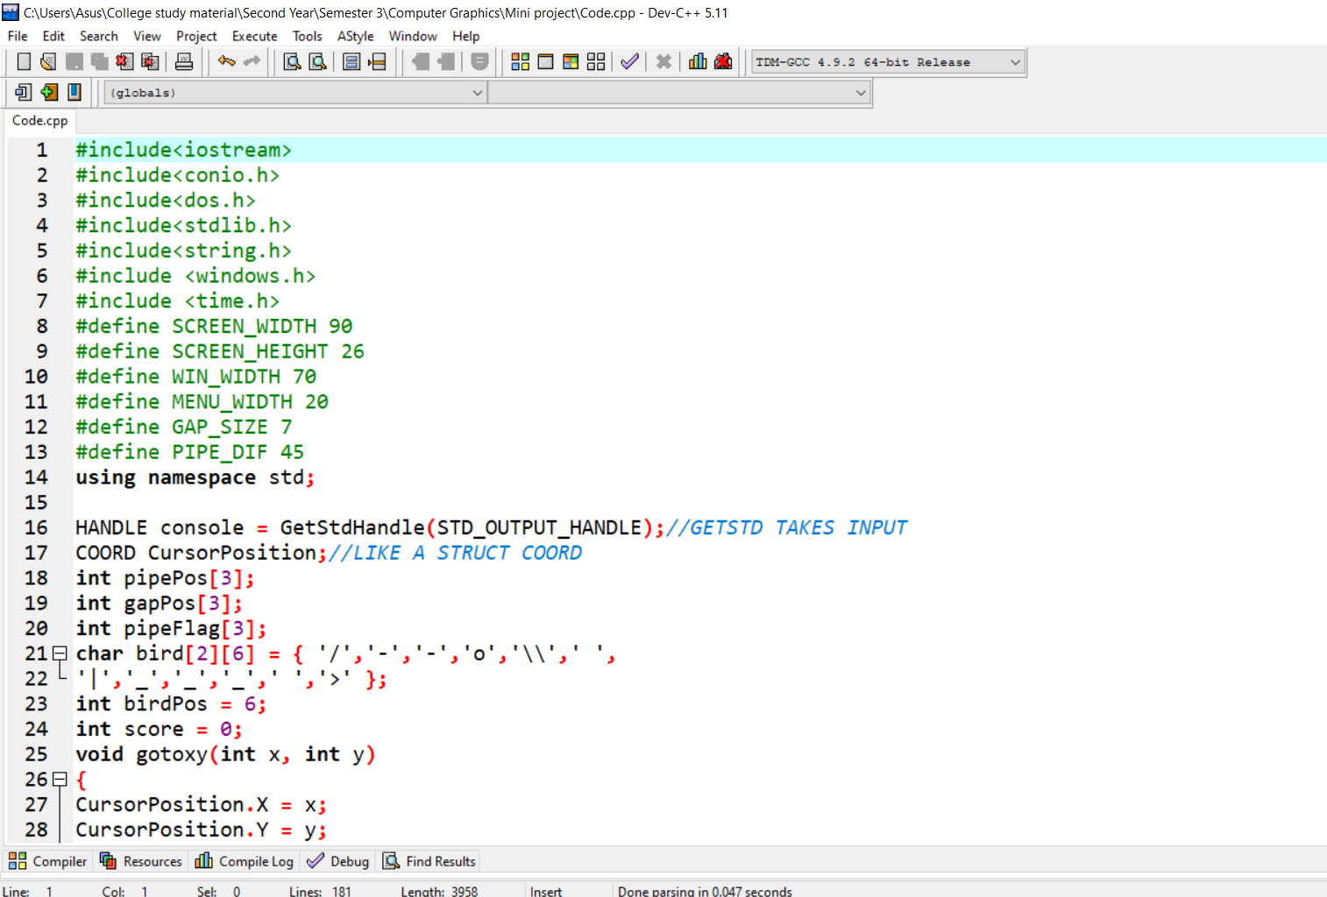

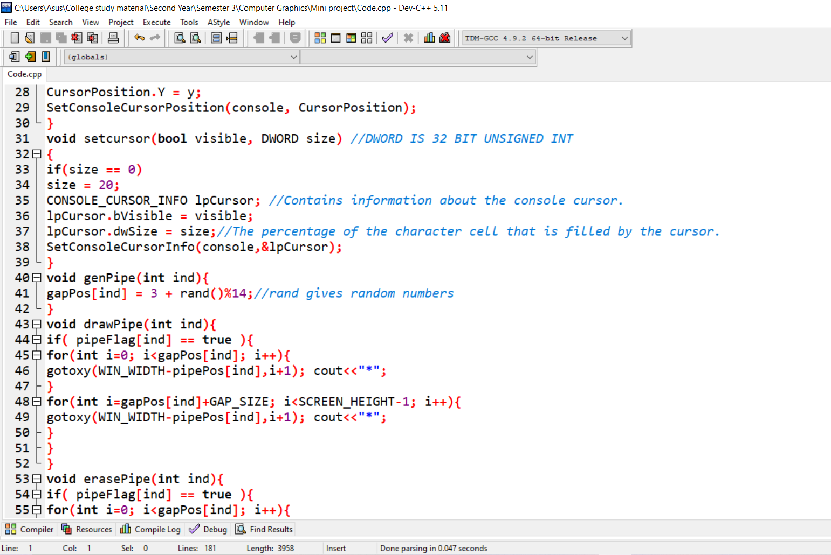

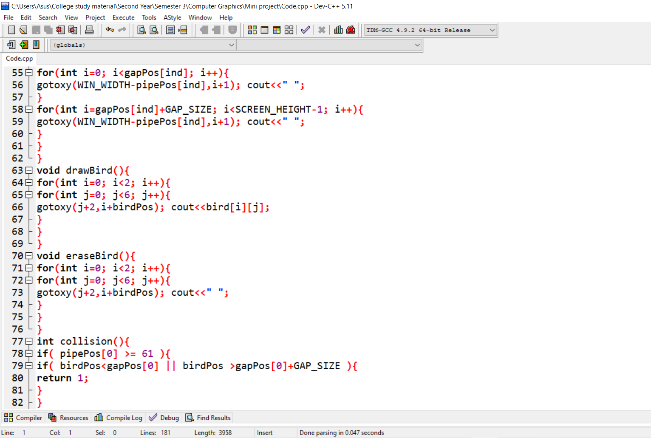

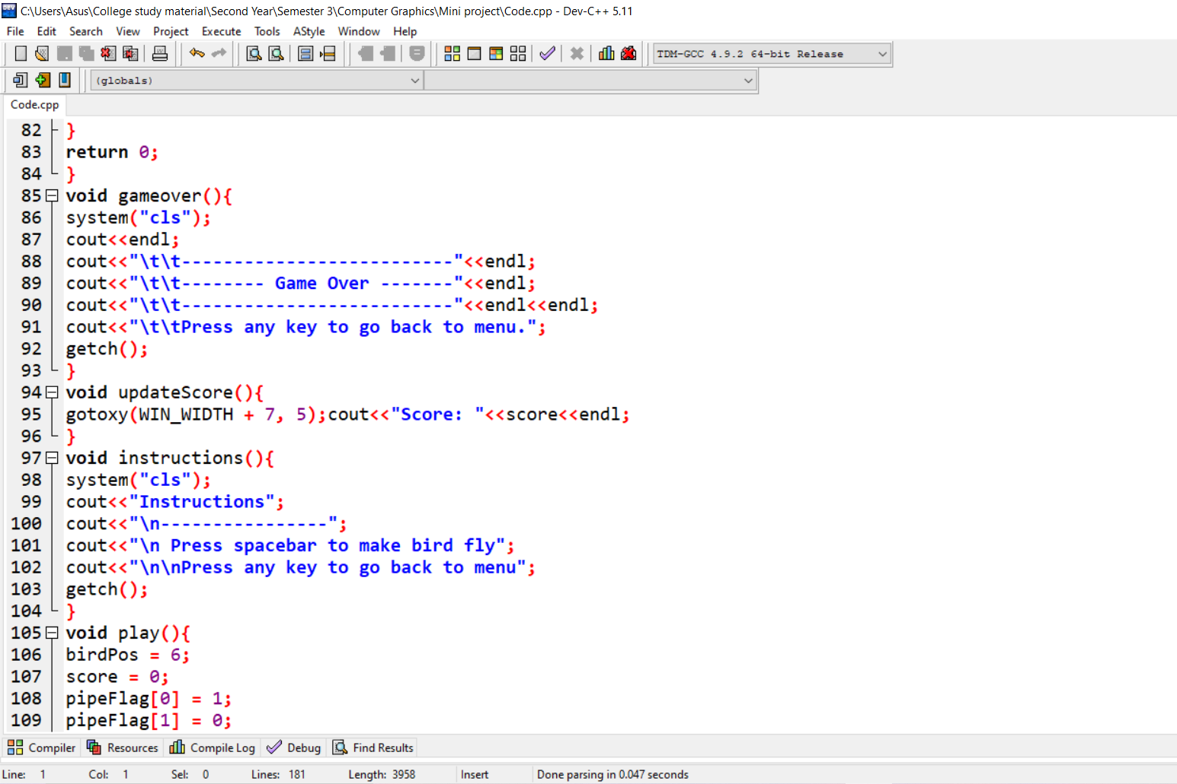

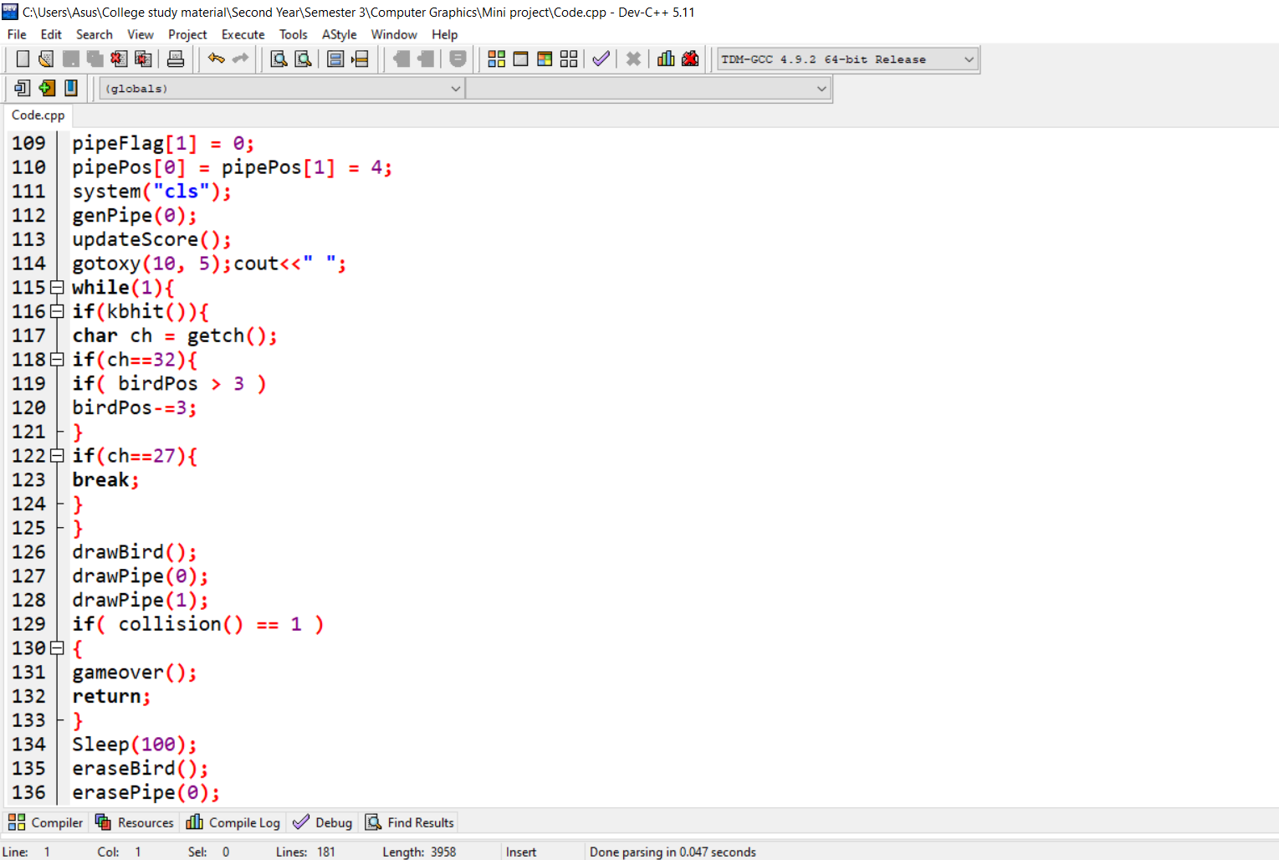

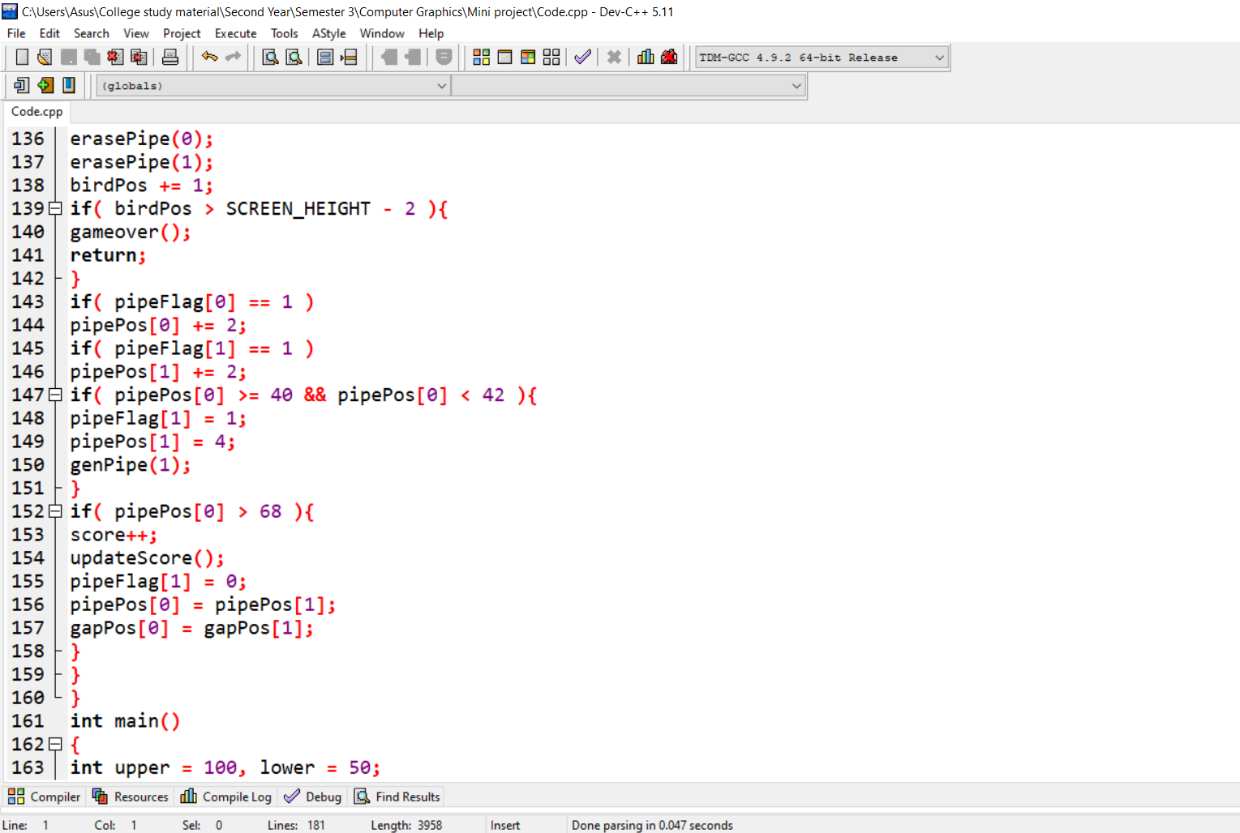

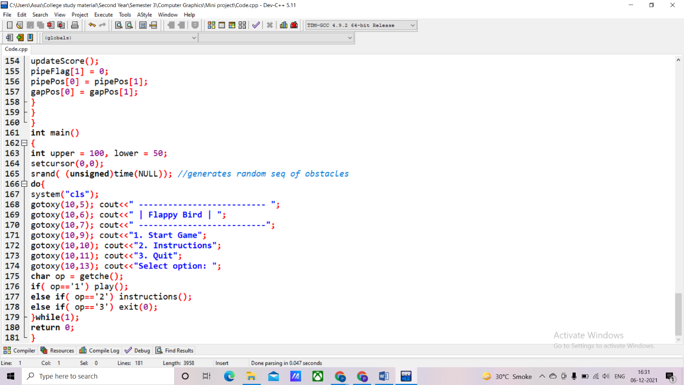

**3.2 Output screenshots:**

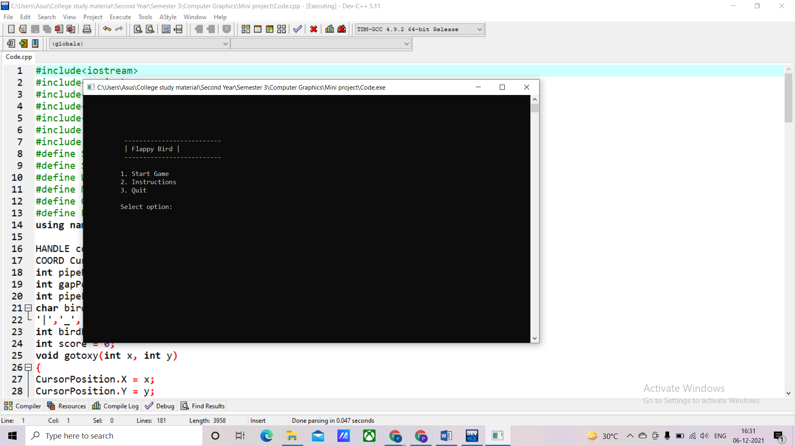

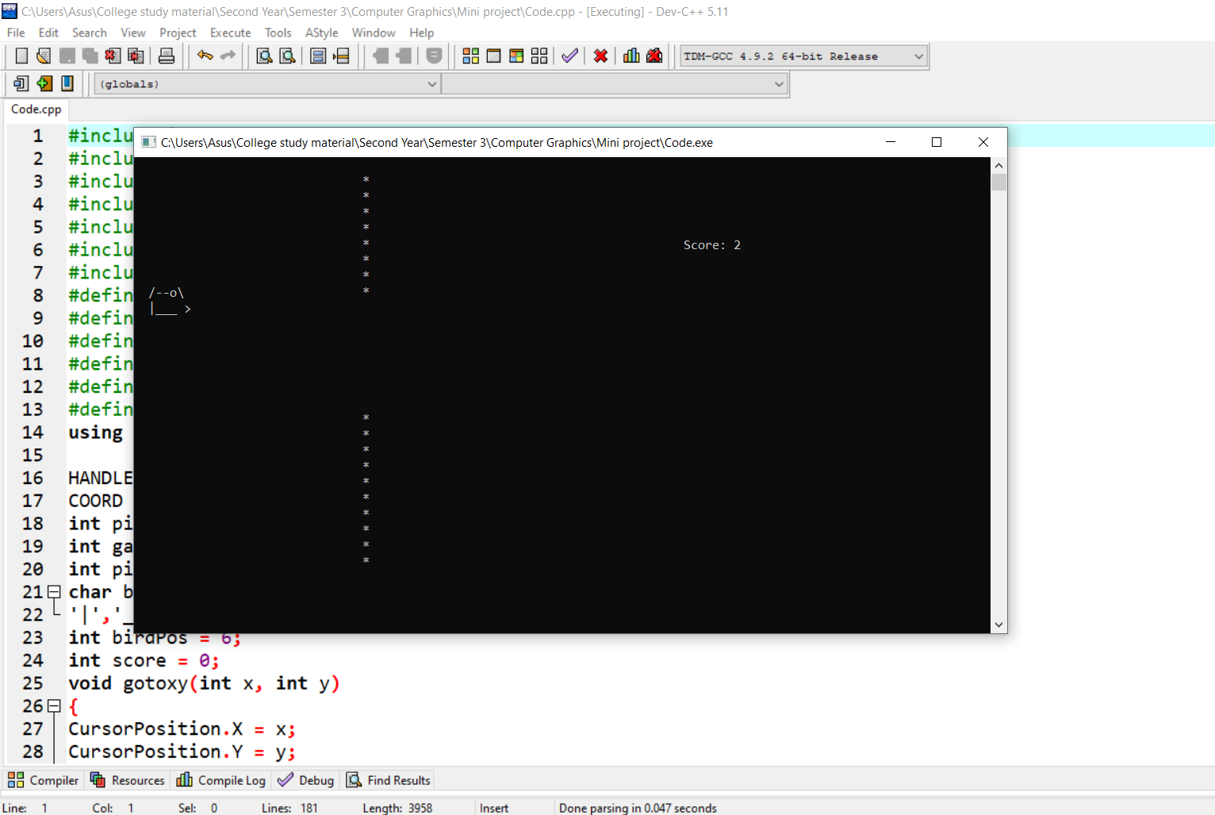

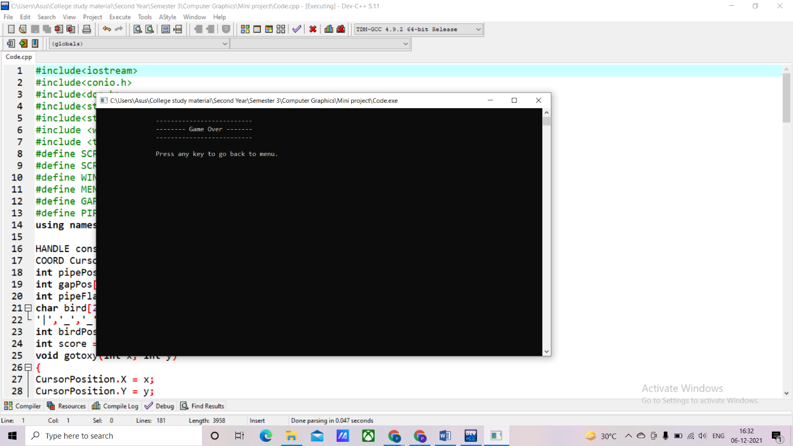

**Chapter 4: Conclusion**

**4.1 CONCLUSION**

Throughout this project, we aimed to develop a flappy bird game that allows users to interact with the game using a keyboard with ease.

The game has no graphics library but has a graphical interface for ease of interaction. The player has to go through all the pipes to win or obtain a high score. The concept is to create a flappy bird game with a graphical interface on the computer without using any graphics library.